The Hon. Bill Graham, PC., QC., Chairman

**and the Board of Directors of**

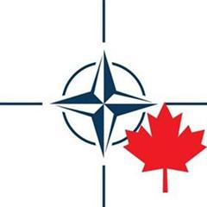

**The Atlantic Council of Canada**

**cordially invite you to the**

#### Annual Tribute Dinner

**honouring**

**Dr. Ignat Kaneff**

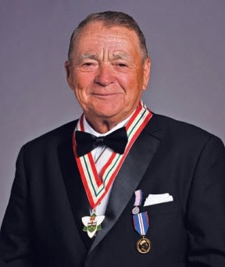

Photo Credit: Bulgarians in Ontario

**Recipient of the Atlantic Council’s**

**2011 St. Laurent Award**

**Lieutenant-General**

**Charles Bouchard**

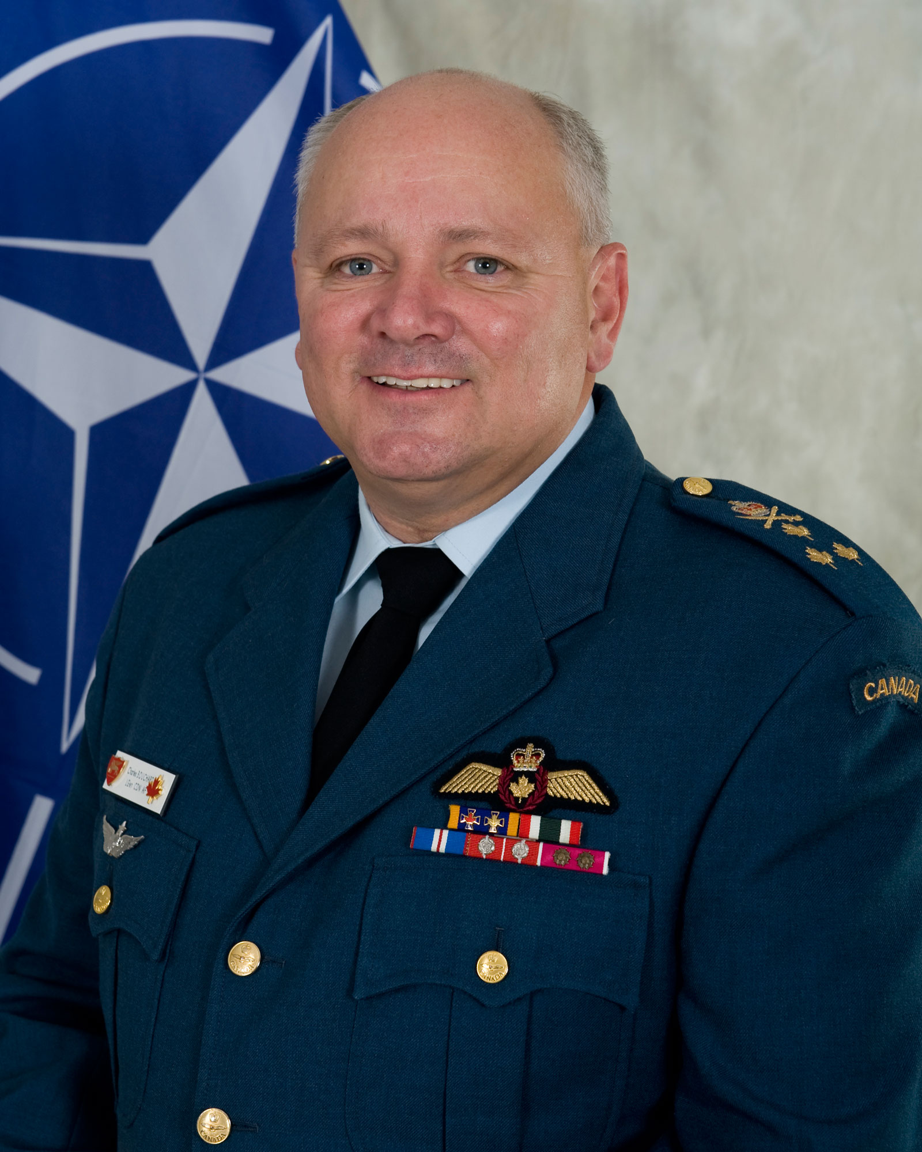

Photo Credit: Allied Joint Force Command Naples

**Recipient of the Atlantic Council’s**

**2011 Award for Exceptional Contribution**

**to International Peace and Security**

**Thursday, April 26th, 2012**

**6:15pm Reception The Great Hall at Hart House**

**7:00pm Dinner University of Toronto**

Dress Code: Business Attire 7 Hart House Circle, Toronto

**…..** **…………………..………………………………………………………………………………………………………………………………………………………….**

**Seating is Limited 🞎 $150** for admission

*To confirm your reservation, please RSVP by phone OR***🞎 $1400** for a table of 10

*Detach and return this form along with your payment***🞎 I/We** are unable to attend but would like to

*by mail or fax by* ***Friday, April 20th, 2012*** Contribute: $ _____________________________

**Name:**

**Telephone:**  **Payment: 🞎 Cheque 🞎 Visa 🞎 MasterCard**

**Email:**   **Card No.** _ _ _ _ **-** _ _ _ _ **-** _ _ _ _ **-** _ _ _ _ **Exp.** _ _ **/** _ _

**Additional Guest(s):**   **Total Included:**

**Signature:**

*Atlantic Council of Canada*

*165 University Avenue, Suite 701* ⬩ *Toronto, Ontario M5H 3B8*

*Tel.: (416) 979-1875* ⬩ *Fax: (416) 979-0825*

*E-mail:* [*rsvp@atlantic-council.ca*](mailto:rsvp@atlantic-council.ca)

**Number of Seats Requested:**

**Important:** *In case of cancellation, the Atlantic Council of Canada will*

*issue a refund less 5% if received 3 working days prior to the event date.*

**…..** **…………………..………………………………………………………………………………………………………………………………………………………….**

**Dr. IGNAT KANEFF**

**Dr Ignat Kaneff** will be presented with the 2011 *St. Laurent Award* to recognize his contribution   
“towards the ideals and principles of maintaining peace and order, which are enshrined in the Washington Treaty.”

In 1956, Dr. Ignat Kaneff founded Kaneff Properties Limited and has gone on to become one of the most successful land developers in Canada.In addition to his phenomenal business accomplishments, Dr. Kaneff has been one of Canada’s greatest philanthropists. He has received the Order of Ontario and a honourary doctorate of laws from York University.

Dr. Kaneff has been a long-time director of The Atlantic Council of Canada and a strong supporter of its work of informing Canadians about NATO and Canada’s role within the Alliance.

###### Lieutenant-General CHARLES BOUCHARD

###### LGen Charles Bouchard will be presented with the *Annual Award for Exceptional Contribution to International Peace and Security* to recognize his “significant contribution to international peace and security, and to furthering the values the founding members set forth in the North Atlantic Treaty: to safeguard the freedom, common heritage and civilization of their peoples, founded on the principles of democracy, individual liberty and the rule of law.”

Lieutenant General Bouchard first enrolled in the Canadian Forces in 1974 under the Royal Canadian Air Force branch. Bouchard was the Deputy Commander for the Continental NORAD Region on September 11, 2001. Most recently, he successfully commanded NATO’s ‘Operation Unified Protector’ in Libya.